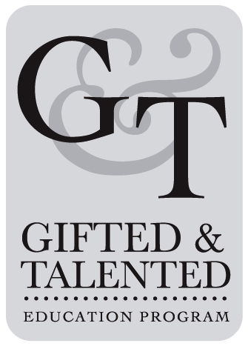
September 11, 2017

Dear Parents of GT Math Students,

We are excited for an awesome year with your student! The GT Math Program is based on the Common Core Curriculum standards and requires a greater understanding of math through exploration and application of mathematical concepts. We foster skills that support and develop problem solving.
Attached is the Grading Policy for GT Math. It should be reviewed, signed, and returned as soon as possible. Students in G/T math are expected to maintain an A, B, or C average for the placement to be considered successful.
Students need to come prepared to begin class promptly each day. All math papers should be kept in their binders in the math section. This is an important study tool for your student. Students will be graded on their organization and completion of assignments. Math textbooks will not go home, but we encourage you to access the online math tools provided through Canvas. Students need to have a spiral notebook, pencils with erasers, lined paper, and agenda book in class everyday. Please label all supplies and check them each quarter to make sure your child is prepared for class each day. Also, your student will need access at home to a 12” ruler with both customary and metric units, a 6” protractor, a compass, a glue stick, and a calculator for homework.
Please do not hesitate to contact either of us if you have any questions or concerns. We look forward to seeing you at Back to School Night on September 19, 2017 at 6 pm. See you then!

Don’t forget to mark your calendar for the Enrichment Fair on May 10, 2018!



Sincerely,

Mrs. Sonya Billey
sonya_billey@hcpss.org

Mrs. Joy Mangiulli
joy_mangiulli@hcpss.org

Approved _____

